Grupos alimenticios

Android Estudio V3.0.17/Flutter

Objetivo: Practicar 1.9 segunda presentación

F.Creación: 5-4-2018

Programa:

Fuente:1.9 segunda presentacion

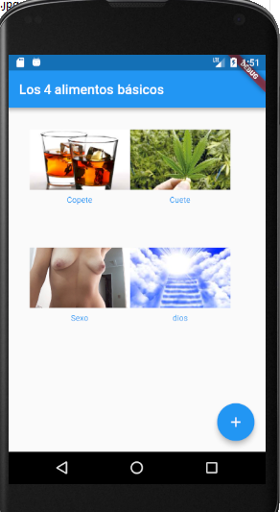

class MyApp extends StatelessWidget {
@override
Widget build(BuildContext context) {
Column chantaCol(String imagen, String texto) {
Color color = Theme.of(context).primaryColor;
return new Column(
mainAxisSize: MainAxisSize.min,
mainAxisAlignment: MainAxisAlignment.center,
children: [
new Image.asset(
imagen,
width: 150.0,
height: 90.0,
fit: BoxFit.cover,
),
new Container(
margin: const EdgeInsets.only(top: 8.0),
child: new Text(
texto,
style: new TextStyle(
fontSize: 12.0,
fontWeight: FontWeight.w400,
color: color,
),
),
),
],
);
}
return new MaterialApp(
title: 'Flutter Demo',
home: new Scaffold(
appBar: new AppBar(
title: new Text("Los 4 alimentos básicos"),
),
body: new ListView(
children: [
new Container(
padding: const EdgeInsets.all(32.0),
child: new Row(
children: [
chantaCol("imagenes/copete.jpg","Copete"),
chantaCol("imagenes/cuete.jpg","Cuete"),
]
),
),
new Container(
padding: const EdgeInsets.all(32.0),
child: new Row(
children: [
chantaCol("imagenes/Lucia01.jpg","Sexo"),
chantaCol("imagenes/dios.jpg","dios")
]
),
),
],
),
floatingActionButton: new FloatingActionButton(
tooltip: 'Add', // used by assistive technologies
child: new Icon(Icons.add),
onPressed: null,
),
),
);
}
}

